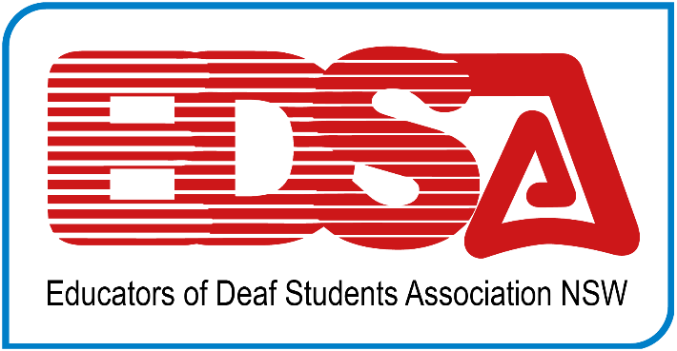
PO Box 43 REVESBY 2212
ABN: 44506431727

FEES ARE DUE: 1st April 2022

The Educators of Deaf Students Association Incorporated NSW (EDSA NSW) is the state branch of the National Association of Australian Teachers of the Deaf (NAATD). The Association strives to keep members informed of current developments in the field by holding regular meetings, producing newsletters, providing 4 issues of Deafness & Education International, the journal of the British Association of Teachers of the Deaf (BATOD) and NAATD, and providing professional leaning opportunities.

MEMBERSHIP CATEGORIES AND ENTITLEMENT

EDSA NSW is a member of National Association of Teachers of the Deaf (NAATD) and has two representatives to all executive board meetings.
All EDSA NSW Members: receive journals, newsletters, NAATD e-Bulletins and support through Teacher of the Deaf meetings/workshops/events.

Full Membership: $110 is only available to qualified Teachers of the Deaf. Full members have voting rights and receive the Deafness & Education International journal.
Two Year Full Membership: $200 This category features all the benefits of full membership, but over two years! You receive a $20 discount across the two years.
First Year Teachers of the Deaf: $0This is a free membership as a welcome to new Teachers of the Deaf. Evidence of your qualification (transcript) is required to qualify for this category. Will receive copies of Deafness & Education International.
Associate Membership: $110 is open to all other professionals and interested persons involved with deaf students. Associate members do not have voting rights and are required to pay full fees ($110) to receive copies of Deafness & Education International.
Retired Membership: $95 is open to past members who have retired. They receive the journal on requested payment.
Student Membership: $95 must be currently enrolled in an accredited course. Will receive copies of Deafness & Education International.
PLEASE NOTE THAT WE NO LONGER USE OUR WEBSITE FOR MEMBERSHIP PAYMENTS

TWO SIMPLE STEPS TO REJOIN OR BECOME A MEMBER FOR THE FIRST TIME:
- Make an electronic bank payment as per your membership category (e.g., full member $110) and record your transaction number and date below.
Account Name: Educators of Deaf Students
Regional Bank BSB: 932000 Account: 737172

PLEASE USE YOUR NAME IN THE RECIPIENTS REFERENCE AND AMOUNT PAID e.g. EDSA Hawkins Alison 110, and we recommend that you record the reference number of your transfer in your diary.

- Complete this form and save for you records and email as an attachment to our Treasurer Donna Rees: donna.rees@det.nsw.edu.au

Name:
Email:
Phone:
Postal Address:
Workplace and Role:

Rejoining member: NAATD Membership Number:

- Full Membership $110
- Two-year full Membership $200
- Free First Year ToD Membership$0
- Associate Membership $110
- Retired Membership without journals
- Student Membership $95

Electronic payment date:
Bank Payment reference:
Amount: $

- FOR NEW MEMBERS ONLY

TEACHER OF THE DEAF QUALIFICATION | INSTITUTION GRANTING QUALIFICATIONS | YEAR GAINED
- I have attached a transcript to this application
Please note new membership will not be processed unless a transcript is provided.

We thank you for your support of EDSA. Your continued membership will enable us to :

- Sponsor speakers both at ITOD and at some regional DoE conferences.
- Continue lobbying for formal adoption of the Teacher of the Deaf Elaborations of the Professional Standards for Teachers with NESA and the re-instatement of accreditation for EDSA Professional Learning events.
- Support the publication of the journal Deafness and Education International which encourages, enables, and promotes professional research.
- Provide a range of online learning experiences including webinars and blog posts.
- Ongoing advocacy work for ToDs in NSW. For example: education systems in other states are changing the way that ToDs provide support for students. These ToDs now provide a more consultative approach of support. EDSA believes this fails to support students adequately, nor does it accord with the legislation. We will be strongly advocating that the NSW Education Department continues in the current model of direct support by qualified professionals.
- Provide feedback to NESA on HSC provisions for students who are D/HH.

Some newsletters which you may like to subscribe to directly for your own ongoing professional learning are:
Deafness Forum One in Six newsletter

https://www.deafnessforum.org.au/news-and-issues/subscribe-to-our-newsletter/

Deaf Child Worldwide (become a member to get the free newsletter)

https://www.ndcs.org.uk/deaf-child-worldwide/

National Deaf Children’s Society
https://www.ndcs.org.uk/information-and-support/

